

AMERICAN INTERNATIONAL UNIVERSITY–BANGLADESH (AIUB)
FACULTY OF SCIENCE & TECHNOLOGY

Spring 2024-25
Section: M

Lab Work (MID + FINAL)

Supervised By K. M. IMTIAZ-UD-DIN

Submitted By
SN | Name | ID
1 | Afnan Bin Islam Nahin | 22-49350-3

Lexical Analyzer Code Skeleton version 1.0
Code:
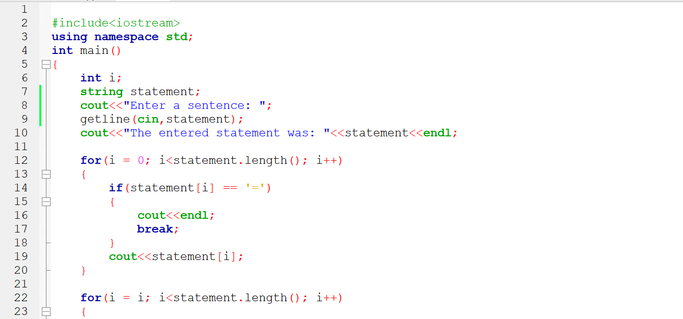
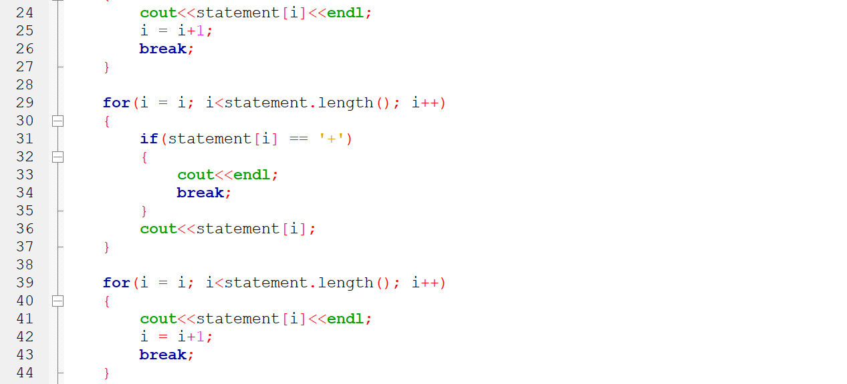
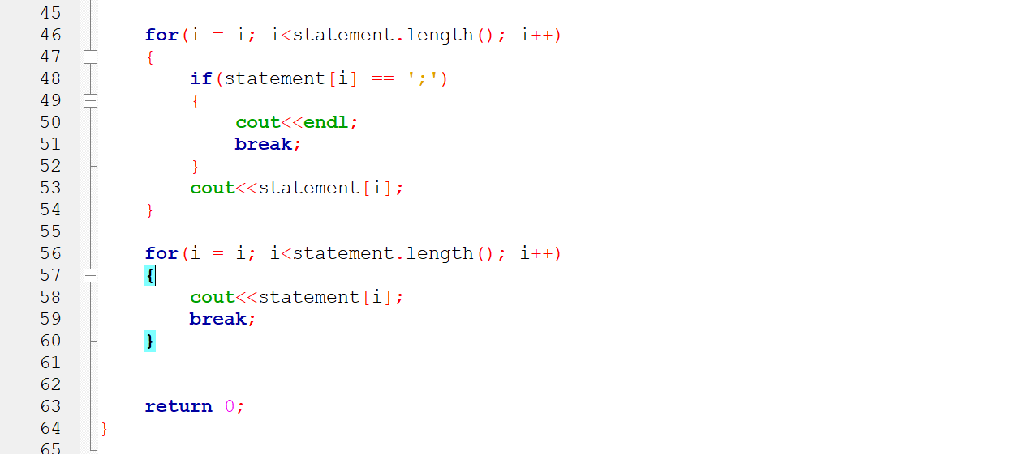
Output:

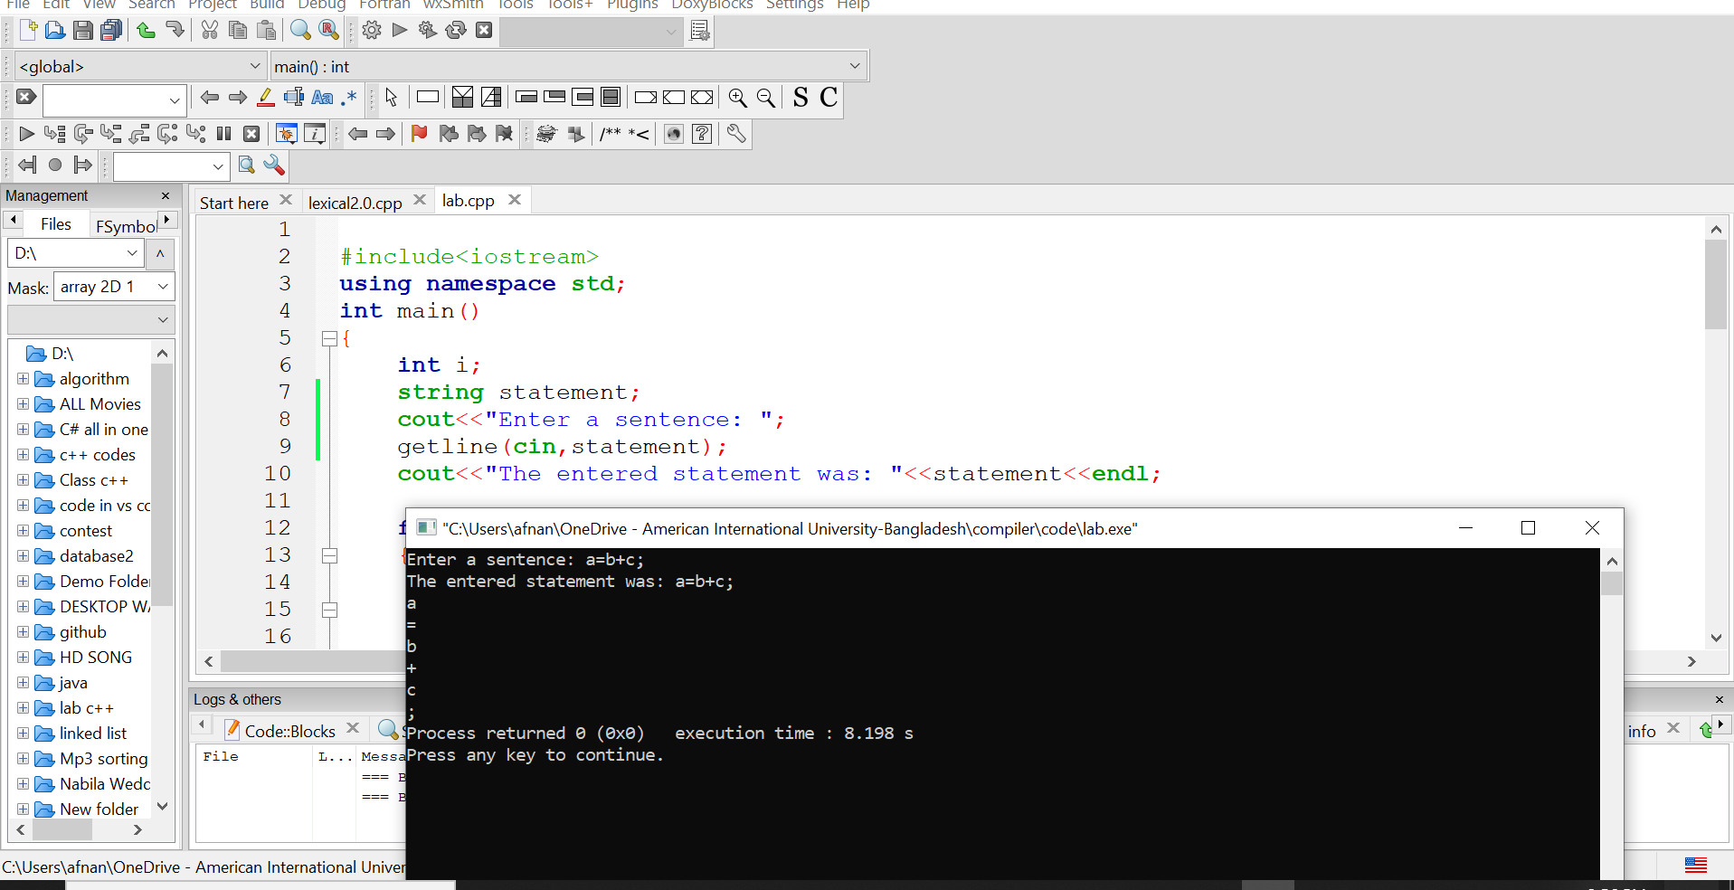

Lexical Analyzer Code Skeleton version 2.0

Code:
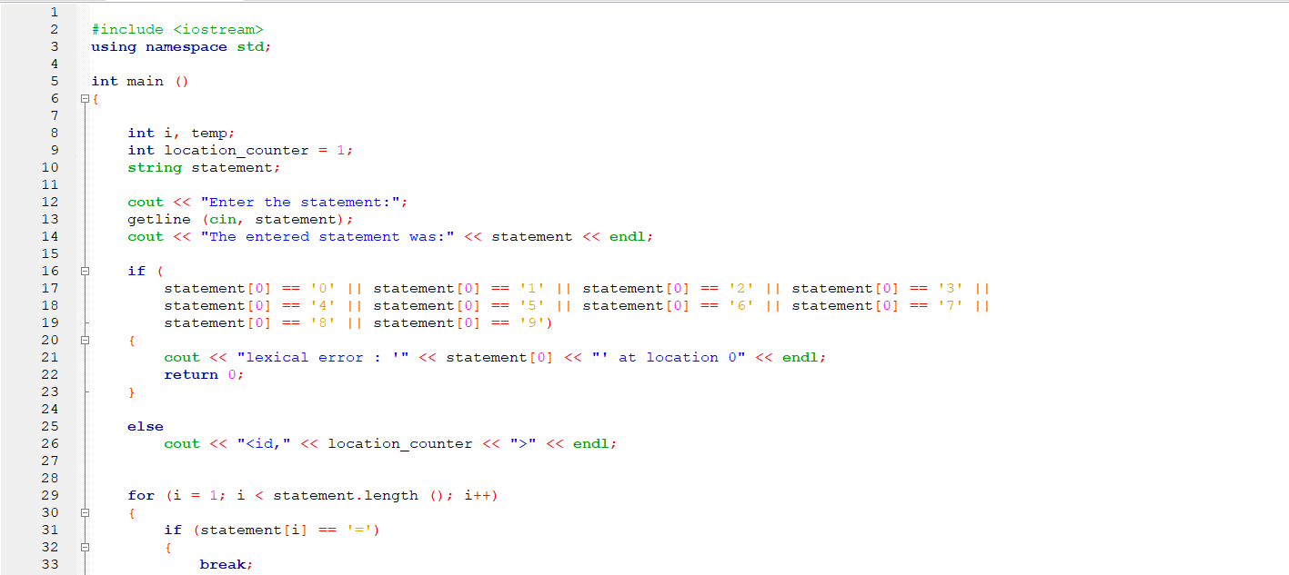
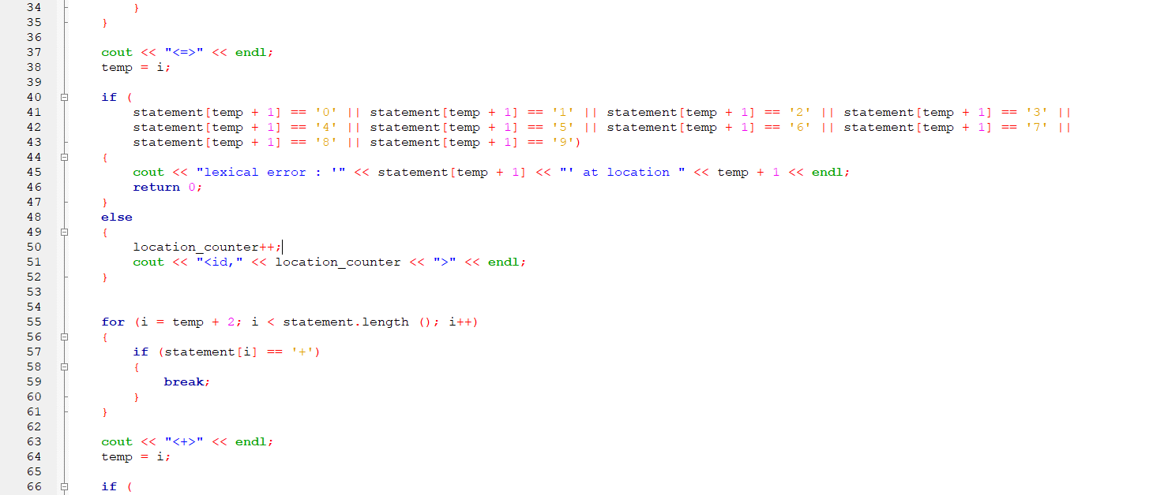
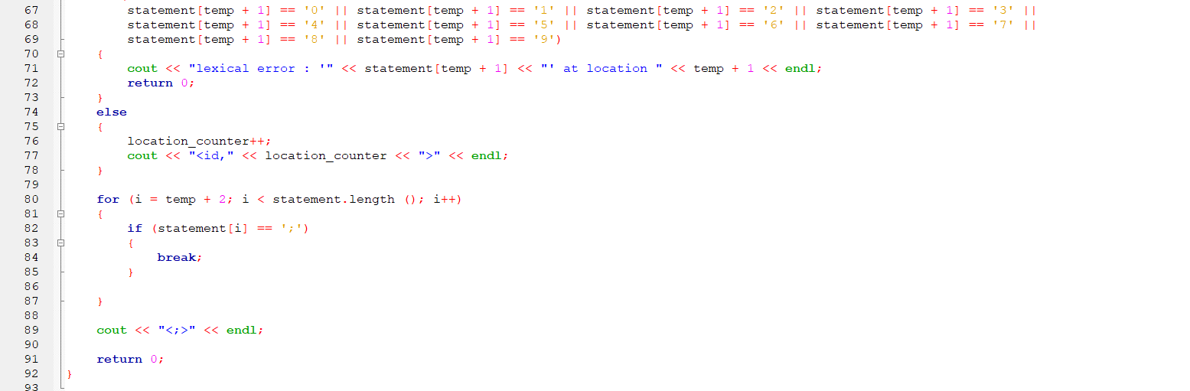

Output:
